NAVAL POSTGRADUATE SCHOOL THESIS REVIEW

Software-Defined Radio Payload Design for Cubesat and X-band communications.

**Spectrum: ***See if we can get a permit to transmit on C-band\*\*\***

* X-band (8-12Ghz)
* Test was done for balloon at C-band (5.75Ghz)

The main purpose behind using X-band is that it is not congested and offers a higher data rate. However, for the balloon testing, they did not receive the permit in time. The amateur radio frequency that the hardware was capable of achieving fell into the C-band.

Requirements/Permits:

The FCC allocates radio frequency use for non-Federal applications and the NTIA does the same for Federal users [13]. In order to use the appropriate X-band frequency channel for the purposes of this research, a Certificate of Spectrum Support from the NTIA and official Radio Frequency Authorization is required.

Test Parameters:

This balloon only went up to 2000 feet. Our balloon will be going up to 130,000 feet.

Data Flow:

From bitstream to digital waveform. Bits are converted to modulation symbols by a bit-to-bit mapper. Modulation symbols are complex-valued functions grouped based on the modulation scheme. The output of the mapper is the complex baseband signal. The purpose of the modulation scheme is to modify the carrier signal with a discrete signal that holds digital data. Each different modulation scheme differs in terms of detectability, simplicity, bandwidth, and bit error rate.

On the way back, the waveform is transformed back into a bit stream, then decoded and reformatted. The receiver must be synchronized with the transmitter in terms of timing, frequency, and phase.

SDR:

Main components are an RF front end, an ADC, DAC, digital front end, and an FPGA.

RF FRONT END: To go from raw RF to intermediate (IF)

On the receiving side, the RF front end amplifies the signal power and converts the center frequency (baseband?) to a range compatible with ADC.

DIGITAL FRONT END: provides channelization, sample rate conversion, and synchronization of the signal for baseband processing. FPGA performs DSP.

Simulation:

Gnu Radio offers the same as MATLAB, is supported for the B205 mini board, and is free and requires less processing power.

Antenna Design:

Dipole and helical antennas are widely used. The length of the antenna in dipole determines what frequency can be attuned to. For dipole, there are two elements that are ¼ center frequency wavelength. Wavelength = speed of light / frequency

Dipole antennas were found to be more forgiving than helical, since the helical antennas require pointing.

Purpose of designed antenna was to output as much energy as possible without added complexity of balun circuit.

*Question: What is a balun circuit.

Antenna was tuned using Keysight FieldFox RF Analyzer and (trimming the edges of the radiating elements). An epoxy covering was applied to the elements and covered with Kapton tape to increase stability.

Link Budget Analysis:

The purpose of LBA is to determine that you have a positive “link margin”, or, the difference between power-to-noise ratio and signal detection threshold, to establish a reliable connection. The link consists of 3 parts: transmitter, propagating electromagnetic signal, and receiver.

Antenna Gain:

Gain is a function of antenna efficiency, diameter, and wavelength. Recommend working in dB to simplify calculations using this equation (watts to dB):

Power decreases as distance increases. Loss occurs from power conversion, line loss, thermal noise, and atmospheric effects. Larger antenna or higher signal frequency increases gain. Increasing power of transmitter also increases SNR. The sum of losses provide total loss (transmitter, receiver, free space, miscellaneous) as a function of distance between antennas.

Energy Bit to noise Ratio:

Used to predict link margin and will factor into modulation schemes. Based on carrier power to noise ratio and the data rate.

Link margin can be defined as the amount above the bare minimum threshold.

Hardware:

ZVBP-5800-S+ Band Pass Filter – precedes high power amplifier and payload antenna. Used to mitigate spurious emissions.

High power amplifier – Due to size and power constraints, they used HPA instead of LNA for the purpose of lower flight testing. Provided about 20dB of gain to the signal.

EPS and Power:

Manages flow of power to other subsystems. 2 lithium iron disulfide batteries in series. Includes sensors that measure, collect, and send voltage, amps, and temp to data handling. This data is included in telemetry data downlink from bus MHX radio. These batteries could handle full discharge for 3 hours.

Use SPOT Trace / GPS receiver for post-flight.

Software:

Recommend using MATLAB Simulink SDR examples to understand functions of GNU Blocks.

The payload rPi camera takes and stores an image. Then the Python script chunker.py, written by NPS Software Engineer James Horning, runs on 45 the payload rPi 3 and “chunks,” or packetizes, the image file. The rPi 3 runs the GNU Radio Python script Cband_Tx.py to transmit the image data via the SDR. Cband_Tx.py encodes, modulates, and transmits the data via the C-band dipole antenna to the ground station.

The ground station is a dish antenna connected to a laptop, that runs python script and Gnu Radio flowgraph. The flowgraph demodulates and decodes received packets. They use 915MHz to send commands and request packets that were lost. Ground station feedback confirms that all packets were received before moving on.

Modulation Scheme:

Gaussian Minimum Shift Keyring – works well for data rate of 9600 baud

The downlink frequency is 914MHz. Not well suited for higher data rates.

­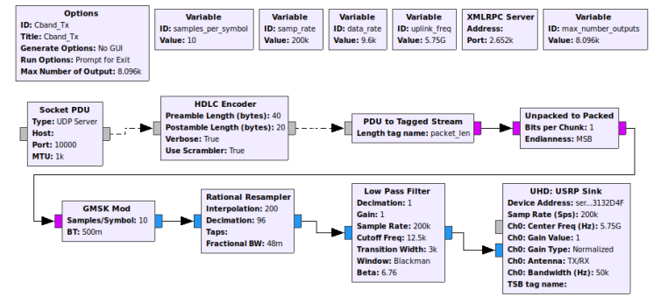

Then, they modified to work at C-band.

The source block is the ground station SDR. The transmitter and receiver use internal clock to measure frequency. Frequency error increases between radios as frequency increases. Mitigated by making receiver center frequency adjustable. Main path of the receiver reverses transmitter flowgraph with the addition of Frequency Xlating FIR Filter block to account for Doppler shift varying center frequency. Parse AX.25 is a python script to conduct ax.25 protocol.

Bus software:

Chunker.py is used to packetize / error correct. Master.py receives and executes commands from ground station, command functions of payload SDR etc., collects and transmits i2c data from sensors to ground. Uses whip antenna.

Bench Testing:

Ran flowgraph and scripts on Linux laptop and connected 2 B205 mini sdr with coax and usb. Used an attenuator between coax to reduce power. Then began over air testing by using Band pass filters and helical antennas, facing one another. This introduced noise to the testing.

Recommendations:

Separate dipole antennas for s-band and x-band balloon tests. Patch antenna for cubesat.

Python Code: